# FRANCE PREŠEREN

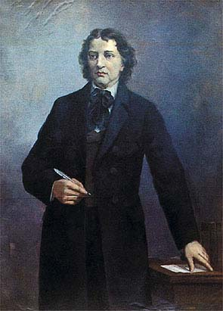France Pešeren is to Slovenians what Goethe is to Germans, Dante to Italians, Pushkin to Russians and Shakespeare to English. He is the greatest Slovenian poet. He is known as the one who inspired virtually all later Slovenian literature, as he became the first modern Slovenian poet and through his poetry Slovenians became the literary equals of other European nations.

Prešeren was born on the 3 December 1800 in the village of Vrba in [Upper Carniolan](http://en.wikipedia.org/wiki/Upper_Carniola), to a peasant family. He finished his law education in Vienna, but he was unable to open his own office until two years before his death in Kranj (20 kilometres northwest of [Ljubljana](http://en.wikipedia.org/wiki/Ljubljana)) .In his poetry he describes his unrequited love for Julija Primic, his poetic calling, and the fate of his nation. His poetic work is collected in the book Poezije (Poems), published in 1847.

He is clearly very important to Slovenian nation, due the fact that his portrait was even on the Slovenian 1,000-tolar note. More on, the anniversary of his death has become a national holiday. His poem »Zdravljica« was selected as the text for the national anthem when Slovenia became independent in 1991. The poem is about nation's freedom and independence and describes mutual understanding between equal, neighboring people. The poem was especially popular during the Second World War.

Prešeren wrote relatively little during his lifetime. Truth be told, almost everything was contained in just one book, Poezije. Prešern as a poet is a symbolic figure for modern Slovenians. In fact, it is little wonder that today he somehow occupies the entire cultural scene. Literature in the nineteenth century greatly aided the formation of the new European nation states' identities, however, nowhere else did literature achieve such importance as in Slovenia. Despite initial doubts about the politics of poets, one must admit that they and their poetry played a large and important role at critical moments in Slovenian national history. In order to confirm one's Slovenian identity, it is sufficient to be convinced that Prešeren excelled in his poetry more than any other in his time or since. He used the Slovenian language to express the most complex personal and social problems and did this in a wondrous way. Since a developed language was one of the key conditions for national identity, Prešeren in fact laid the groundwork for an independent Slovenian identity.